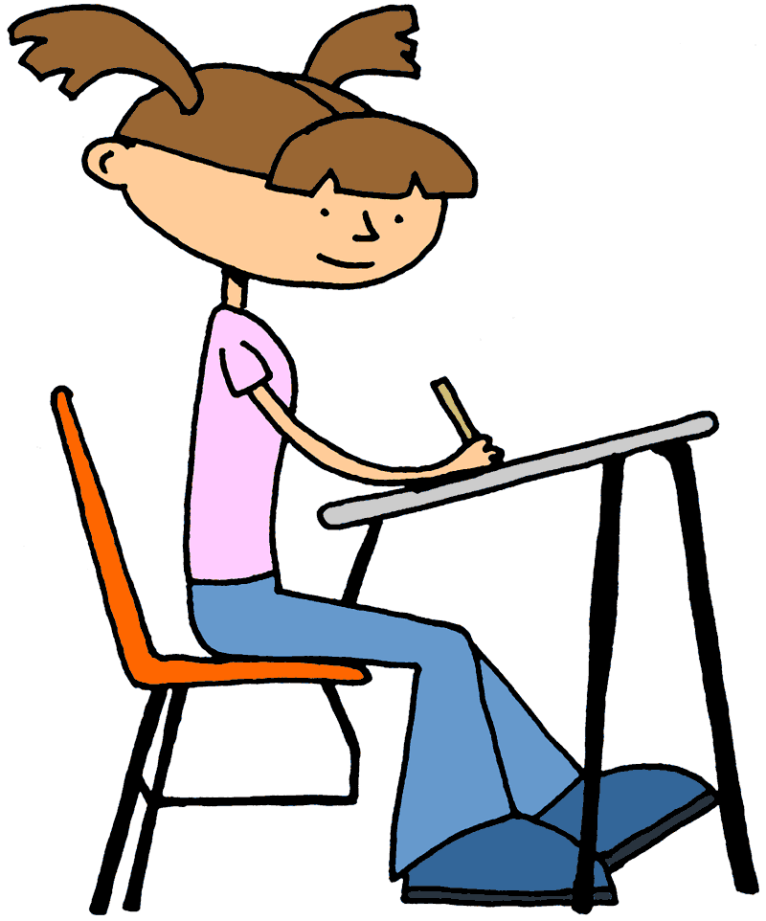
Shadow Hills 2019-2020
4th & 5th Grade
Suggested
Student Supplies

- backpack
- 3-ring binder that zips closed (best option) or accordion-style binder

The following items must fit in the binder to be easily transported between each of your child’s classrooms:

- lined notebook paper – wide ruled or college ruled
- subject notebook dividers, with pockets (if using 3-ring binder)
- 2 Composition Books, 100 pages (to be used as Math journals)
- 2 Spiral notebooks – single subject, 70 or more pages
(to be used as English Language Arts and Social Studies journals)

- pens – black or blue only
- pencils - #2
- erasers - pencil top or bar
- pencil sharpener – small, non-electric, enclosed
- highlighter – yellow

All students must wear closed toed shoes that are suitable for daily physical education activities. Flip flops or sandals are not allowed.

Healthy snacks and water bottles are highly encouraged.

Please let us know if you have any questions!
You may also find our website helpful …hernandezakateacher.weebly.com

Mr. Steve Cornell Mrs. Tina Krawczyk Mrs. Liz Meade
Maestra Michao Martin Maestra Keala Rusher

scornell@alpineschools.net tkrawczyk@alpineschools.net
lmeade@alpineschools.net mmartin@alpineschools.net
krusher@alpineschools.net

